**You should deep clean your Windows PC every year to keep it running smoothly — here's how I do it**

Story by João Carrasqueira

It's often overlooked, but in order for a computer to keep working at its best, you need to take care of it. That's true of any piece of equipment, really — improper handling leads to more wear and tear. But with computers, it's especially easy to be careless, because the kind of care you need to take isn't as physical (though you most certainly should also be careful there), and has more to do with software.

We tend to assume that computers will just keep working as well as they always have without any need for upkeep, but that's not true. And if you want to keep your [Windows 11](https://www.xda-developers.com/windows-11/?utm_source=syndication&pubDate=20250812) PC running smoothly, it's a good idea to take some time every year to do a big cleanup to ensure it's in top shape. You can do it even more frequently, too, but once a year is what I'd consider the minimum that's still reasonable for everyone. So how do we go about this cleanup? I'm glad you asked.

**Uninstall apps**

**Taking out the trash**

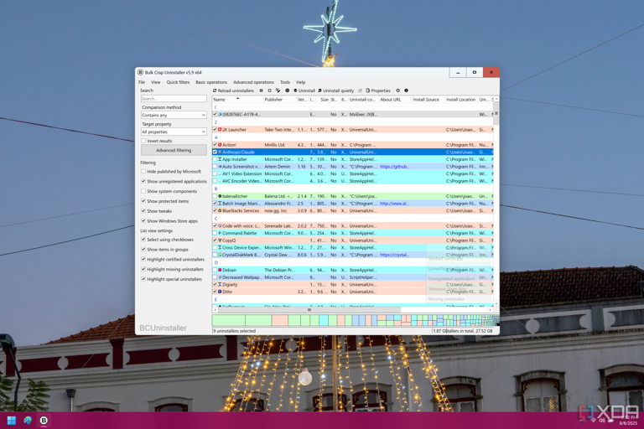

Screenshot of BCUninstaller showing a list of apps tha can be uninstalled, with various items already marked for deletion

As you use your computer, there's a good chance you need to install new programs every now and then. That's certainly true for me, as testing [different programs](https://www.xda-developers.com/tiny-open-source-apps-replace-windows-bloatware/?utm_source=syndication&pubDate=20250812) is a huge part of my job, which often means filling my laptop with junk. And what happens most of the time is that we just end up forgetting to remove the programs once we've used them, even if we don't need them anymore.

This is the first place to start your cleanup. You can uninstall apps using the Settings app, but I actually recommend using a program like BCUninstaller. This program will scan your PC for apps installed with typical methods, but also apps managed by programs like [Chocolatey](https://www.xda-developers.com/chocolatey-is-an-amazing-package-manager-for-windows/?utm_source=syndication&pubDate=20250812), the Microsoft Store, and even portable apps, with the last one of those being configurable so you can have the program check specific folders. The B in BCUninstaller stands for "bulk", and that means you can uninstall all these apps in one fell swoop.

After selecting all the apps you want to uninstall, you can use the **Uninstall quietly** option, which tries its best to remove programs without requiring interaction. If you need to step away from the computer for a bit, this may allow that, but BCUninstaller will also let you know of installers you selected that don't allow quiet uninstalling, and it will go through those earlier on. That way, when you finish all the "loud" uninstallers, the program will also let you know when it should be safe to move away from the computer and let it do its thing.

What's more, after all the uninstallers are done, BCUninstaller can even look for leftover files for all of them to really clean up after the apps you just removed. It's incredibly useful and does a fantastic job of getting your computer back in top shape.

**Run a debloat script**

[**https://www.youtube.com/watch?v=mwUBeqHqSas**](https://www.youtube.com/watch?v=mwUBeqHqSas)

**Gemini AI Explanantion:**

A debloat script for a Windows computer is typically a PowerShell script designed to remove pre-installed applications (bloatware), disable unnecessary services, and modify settings to improve system performance and privacy. These scripts aim to streamline the operating system by eliminating features and applications deemed non-essential by many users.

Common features of a Windows debloat script:

* Removal of Universal Windows Platform (UWP) Apps:

Uninstalls pre-installed applications like Xbox apps, Mail and Calendar, Groove Music, and others that may not be used.

* Disabling Telemetry and Data Collection:

Modifies settings to reduce or disable data collection and telemetry features that send user data to Microsoft.

* Disabling Unnecessary Services:

Stops or disables background services that consume system resources but are not critical for typical usage. Examples include certain diagnostic services, print spooler (if not using a printer), or fax services.

* Privacy Enhancements:

Adjusts privacy settings related to advertising IDs, location services, activity history, and app permissions.

* Removal of Intrusive Interface Elements:

Can remove or disable elements like Cortana, Bing search integration in the Start menu, or targeted ads within the interface.

* Optimization of System Settings:

May include tweaks to improve performance, such as disabling visual effects or optimizing power plans.

Examples of well-known debloat scripts:

* Windows10Debloater (compatible with Windows 11):

A popular PowerShell script available on GitHub that offers interactive, silent, and GUI versions for removing bloatware and optimizing Windows.

* Win11Debloat:

Another PowerShell script specifically designed for Windows 11, focusing on removing default apps, disabling telemetry, and decluttering the interface.

Important Considerations:

* Backup:

Before running any debloat script, it is highly recommended to create a system restore point or a full backup to revert changes if unintended issues arise.

* Review the Script:

Users should review the script's code before execution to understand precisely what changes it will make to the system.

* Potential for Issues:

While debloat scripts aim to improve performance, aggressive debloating can sometimes lead to unexpected issues with certain applications or system functionalities.

**Remove Microsoft junk**

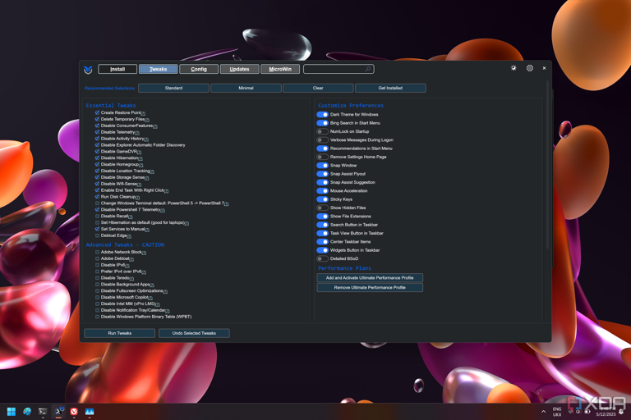

Screenshot of the Tweaks panel in Windows Utility

Debloat scripts are often best run when you first get a new computer, and ideally, you wouldn't have to worry about it again. But as Windows receives updates, it can sometimes add new bloatware, or re-enable features and settings you've disabled before. If you're doing an occasional cleanup, it doesn't hurt to run one of these scripts again to make sure Microsoft junk isn't filling up your PC and making for a worse experience.

One of the best options for debloating is [Chris Titus Tech' Windows Utility.](https://www.xda-developers.com/want-debloat-windows-free-open-source-tool-one-of-best-out-there/?utm_source=syndication&pubDate=20250812) This tool provides a centralized way to disable all kinds of telemetry and other privacy-invasive features, and it even includes an integration with O&O ShutUp 10 to offer even more detailed options for disabling things you don't need. I've previously covered this app in more detail, but the best way to go about it is to look carefully through the options and see what you can disable. The only things I wouldn't touch are the update settings and MicroWin, as you really shouldn't disable Windows updates, and MicroWin is used to create a new Windows installation.

Unlike some other utilities of this kind, there's no section dedicated to uninstalling built-in apps, but we've already kind of covered in the first section.

**Disable startup apps**

**Quiet down, please**

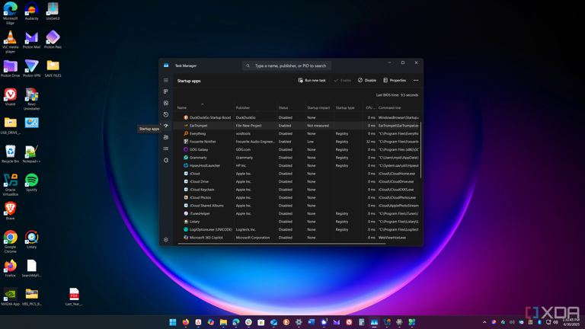

Screenshot of a Windows desktop showing startup tasks in Task Manager

Even if you choose to keep certain apps on your PC, you might not realize that some of these apps will try to start alongside your PC, taking up resources in the background and making your computer take longer to boot. It's a good idea to keep an eye on your PC's [startup tasks](https://www.xda-developers.com/how-turn-off-startup-tasks-windows-11/?utm_source=syndication&pubDate=20250812) as well, to make sure that nothing is slowing you down.

The best place to start is by looking at Task Manager, which you can open by right-clicking the taskbar and choosing **Task Manager**. If you head over to the **Startup** tab (marked by a speedometer icon), you can see a list of the apps that have startup tasks created, as well as whether those tasks are enabled or disabled. You can disable the vast majority of these without breaking your PC, but some of them may alter some functionality you're accustomed to. For example, if you disable Microsoft Teams, you won't get message notifications until you actively open the app. It's a matter of disabling things in stages and seeing how it affects the usability. If anything stops working as expected, you can always re-enable that task.

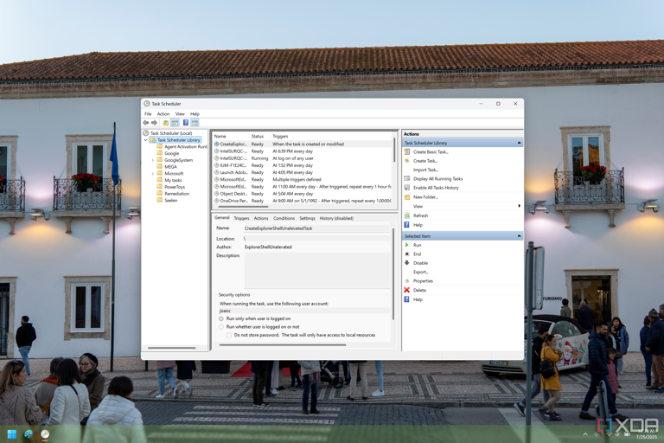

Screenshot of Task Scheduler on Windows 11 displaying the contents of the generic library folder

Another good place to check is **Task Scheduler**, though this requires a bit more of an attentive eye. A lot of how Windows operates is based on scheduled tasks that do things like checking for updates for specific apps. Here, you'll have to look carefully through the tasks that are listed and also look at their triggers. Your focus here should be on tasks that are triggered at log on, so take a look through it and see what may or may not be useful to you.

**Check for driver updates**

**Make sure everything is running smoothly**

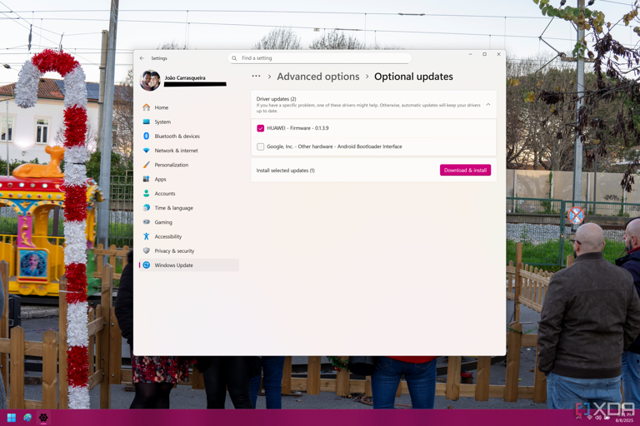

Screenshot of Windows 11 Settings showing available driver updates on Windows Update

While "cleaning up" usually means removing things, it's also a good idea to take some time to [install any driver updates](https://www.xda-developers.com/how-to-update-drivers-in-windows-11/?utm_source=syndication&pubDate=20250812) you may have missed in the last few months. Windows Update will usually install critical driver updates automatically, but if you go into the **Advanced options > Optional updates** page, you might find some extra driver updates that can be good for your device.

For [graphics drivers](https://www.xda-developers.com/how-to-update-graphics-driver/?utm_source=syndication&pubDate=20250812), your best bet is typically to head to Nvidia, AMD, or Intel's websites and download the latest version, which will usually also include management software that makes it easier to download and install future driver updates.

For anything else, it's best to look into your computer manufacturer's website, or check if the company includes an update manager of its own, which is also likely. This will provider things like BIOS updates and other drivers that are approved for your specific device.

Windows itself should stay up to date automatically, so you shouldn't have to do much, but it never hurts to check for the latest updates.

**Run a malware scan**

**Better safe than sorry**

I'm a firm believer that the [best antivirus](https://www.xda-developers.com/best-antivirus-windows-11/?utm_source=syndication&pubDate=20250812) is common sense, but not everyone is in tune with all the potential threats on the internet, and even more tech-savvy users venture onto dangerous websites sometimes. When doing a deep clean, it's a good idea to also check for viruses on your PC, and in my opinion, there's no better anti-malware solution than MalwareBytes.

The free version of MalwareBytes doesn't offer real-time protection, but it can still run a deep system scan, and it's got one of the best detection engines in the business, at least as far as free options go. For an occasional scan like this, it's perfect. Simply install MalwareBytes and run a scan with every option enabled, then go about your life. The scan will probably take a while, so you might want to find something else to do while you wait.

**Delete temporary files**

**A little more cleanup**

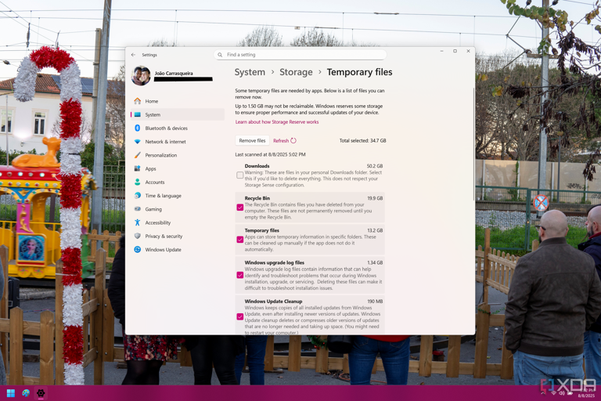

Screenshot of the Windows 11 Settings app showing temporary files to be deleted

Finally, it's time to [delete temporary files](https://www.xda-developers.com/how-clear-cache-windows-11/?utm_source=syndication&pubDate=20250812) on your system. These probably won't hurt your performance significantly, but freeing up space for more important files isn't a bad thing, and having a drive that's too close to being full can actively hurt its performance, so it's not a bad thing to do.

Contrary to popular belief, you don't need a third-party app to clean up your drive. My recommendation is using the Settings app, and heading into **System > Storage > Temporary files**. Your PC will scan for all kinds of cache files that are no longer needed, such as Windows update remnants, thumbnails, and so on. Once the scan finishes, you can safely select **almost** every option here, except the **Downloads** folder, which will likely delete everything you've ever downloaded. I do recommend you go through your Downloads folder manually beforehand and delete anything you don't need from there, but checking the box here will just remove everything, which could be a big problem.

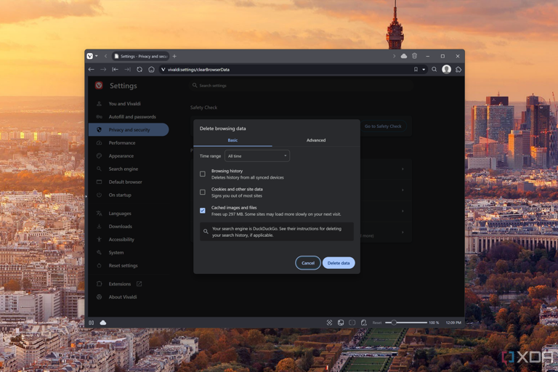

Screenshot of Vivaldi settings showing the dialog for clearing browsing data

What you may also want to do is go into your web browser and open its settings to manage the cached files there. Browsers can also pile up a lot of files that aren't necessary, so an occasional cleanup won't hurt. Getting to these settings will vary by browser, but generally, entering **chrome://settings** or **firefox://settings** in the address bar should take you there, and then it's a matter of looking for the **Privacy** section to clear your browsing data. Keep in mind the only thing you really want to delete here is **Cached images and files** or something equivalent. Checking every box could actually cause you some problems, so don't be too hasty with your clicks.

**Clean PC, clean mind**

Taking these steps every few months or every year is going to be a tremendous help to keep your PC running smoothly. Sometimes, it may not be enough, and you may need to either reswet your PC or simply get a new one, but if you want your machine to last as long as possible without that kind of hassle, it's best to do what we've recommended here.

Of course, it's also a good idea to be mindful throughout the year. Delete files you don't need and keep things organized so it's easier to tell what's important and what isn't, and try to avoid shady websites and programs. All of them will make for a better experience in the long run.